1. Configure VPC peering in cross regions.

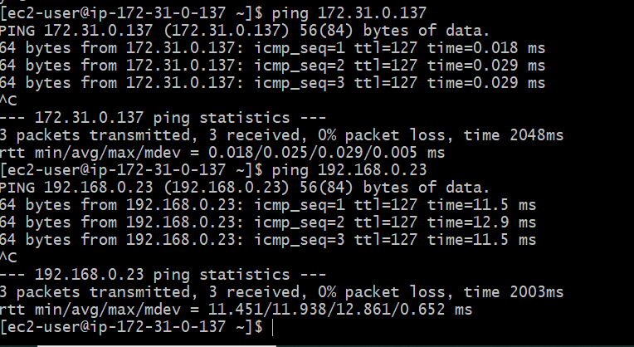

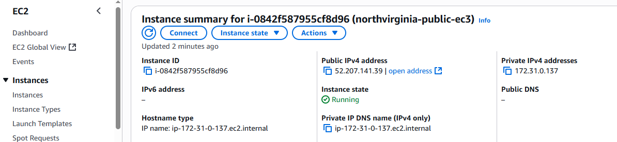

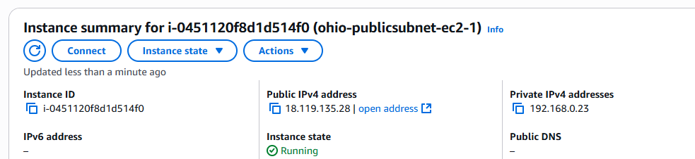

1. Purchase one domain from godaddy.

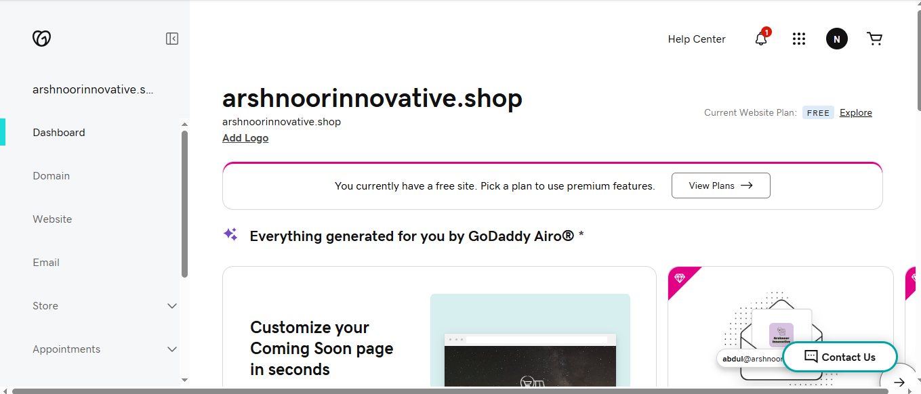

1. Deploy static webiste in s3.

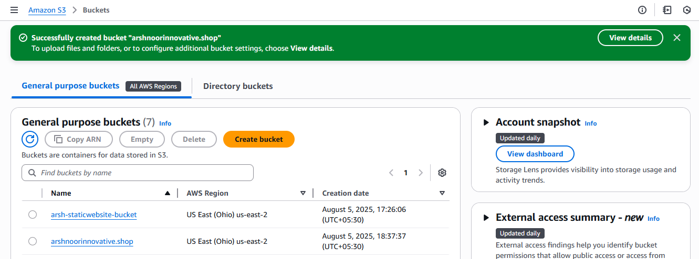

Arshnoorinnovative.shop

iss my domain

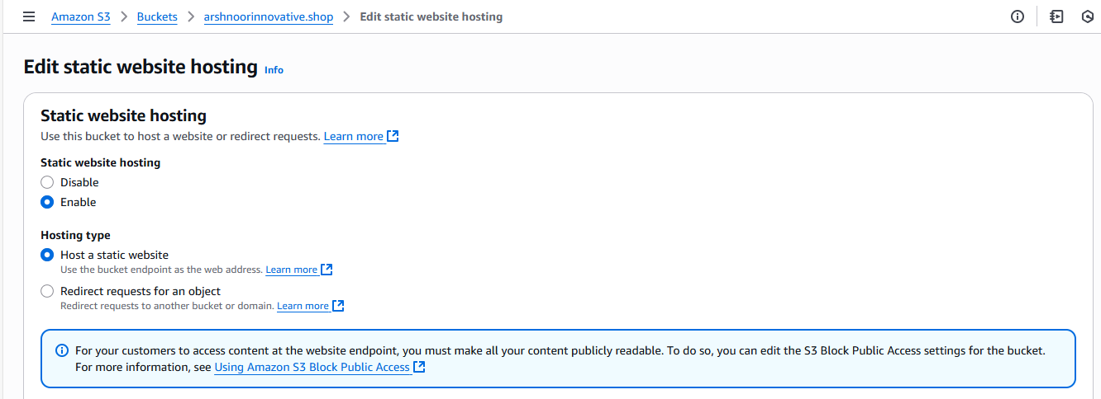

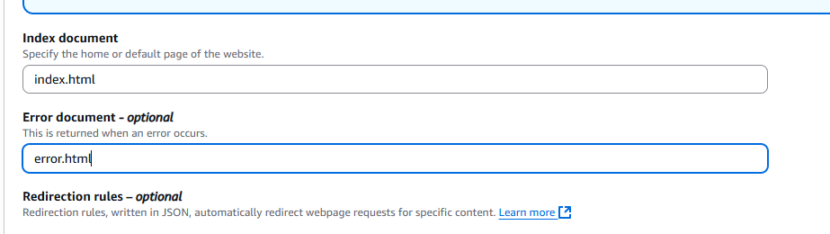

Save changes

Let upload 2 objects files index.html and error.html

Create 2 iles in bash – desktop location

Vi index.html

Vi error.html

Then “make it public” to 2 objects

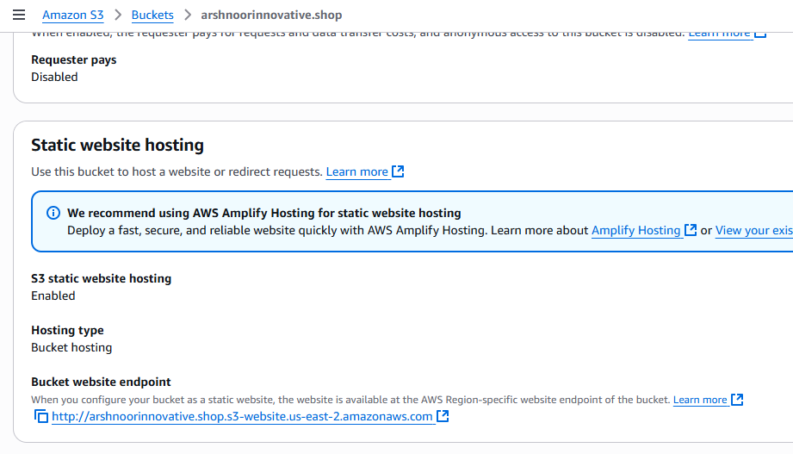

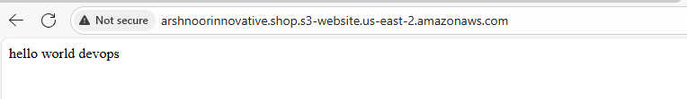

1. Create CDN and attach one SSL certificate.

CDN stands for cloud front distribution network

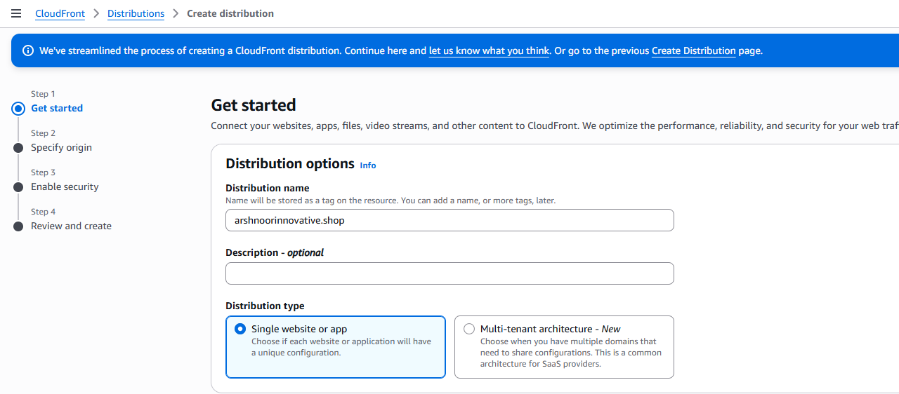

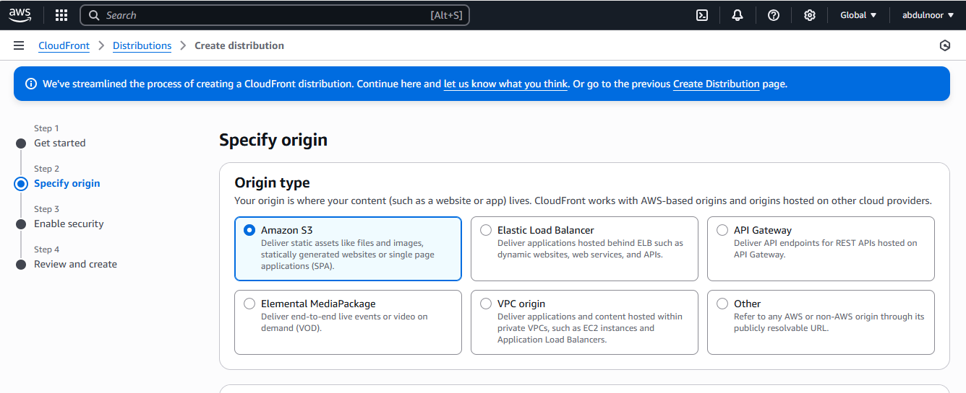

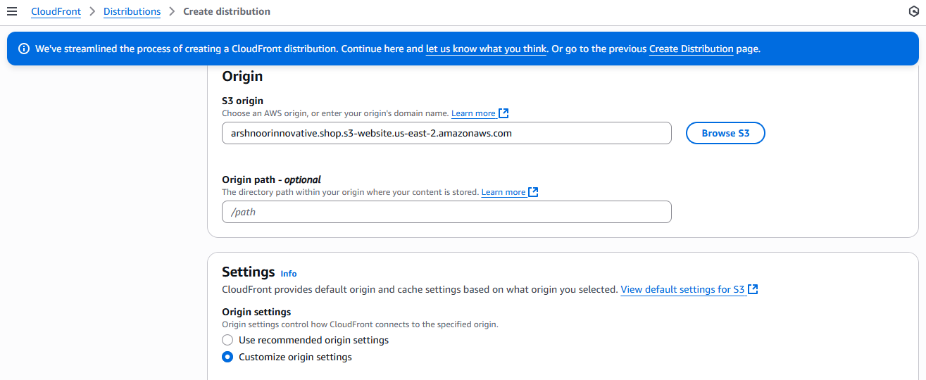

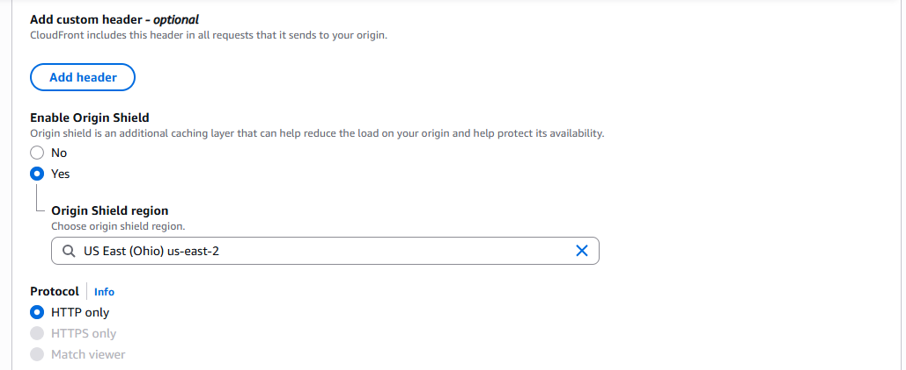

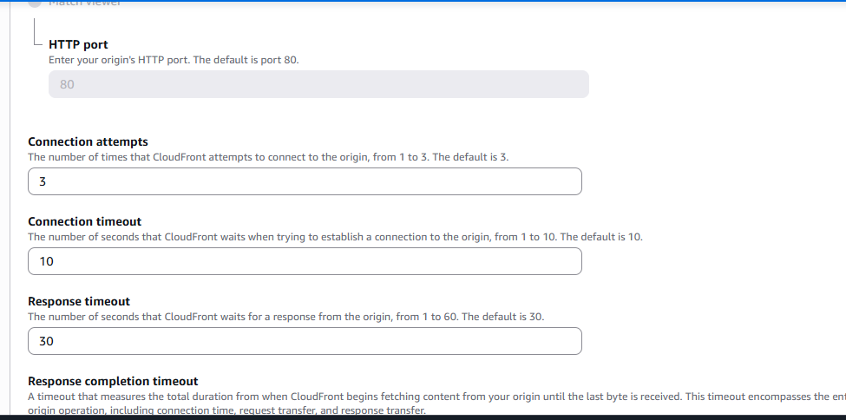

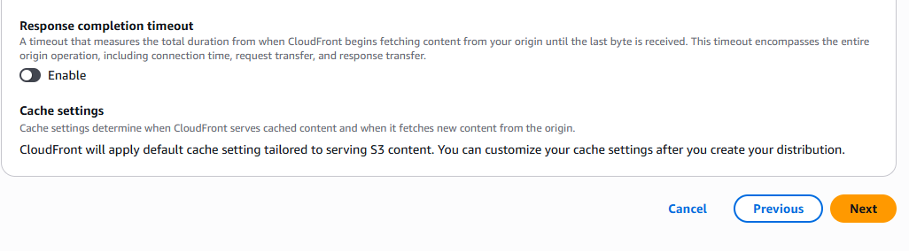

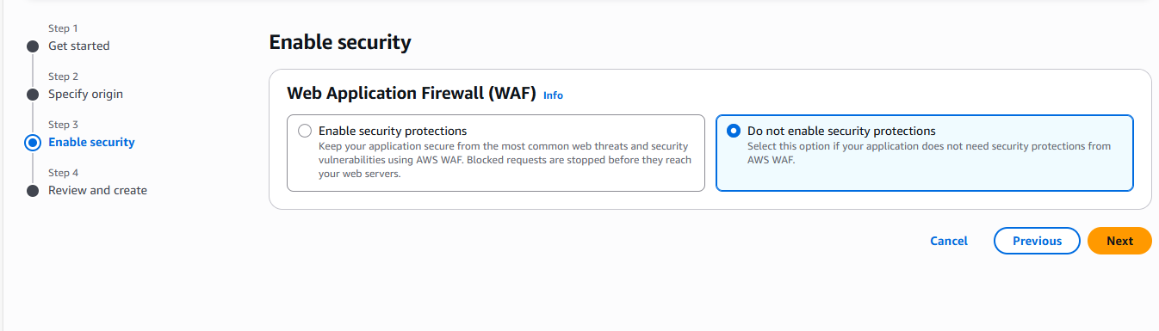

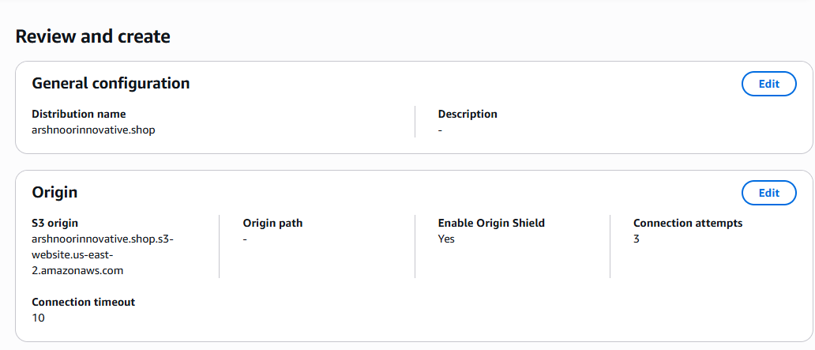

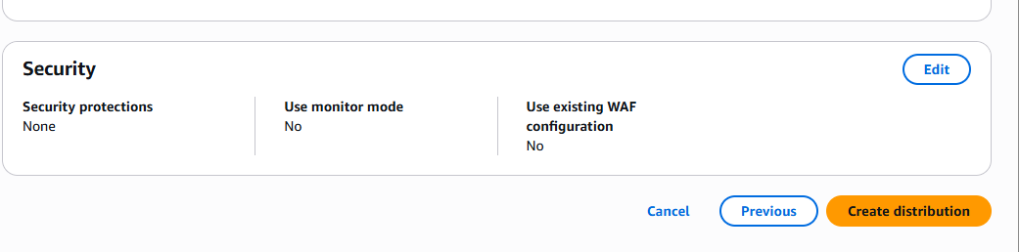

Click on create distribution

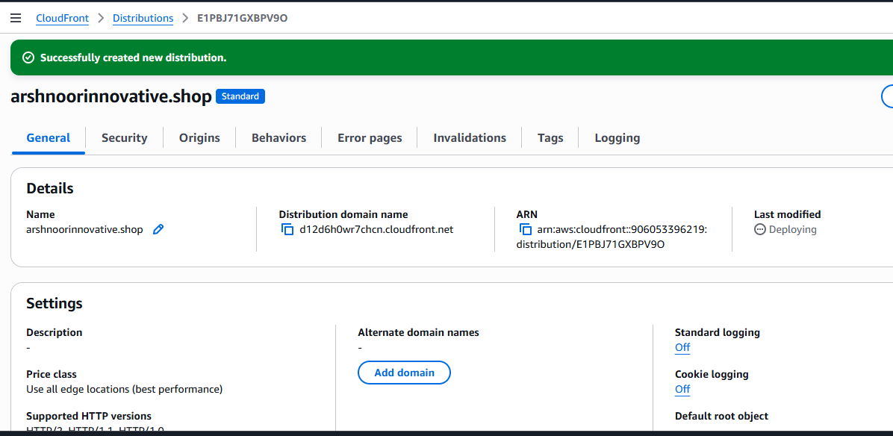

SSL certificate and see also the complete CDN an SSL in task 6 also.

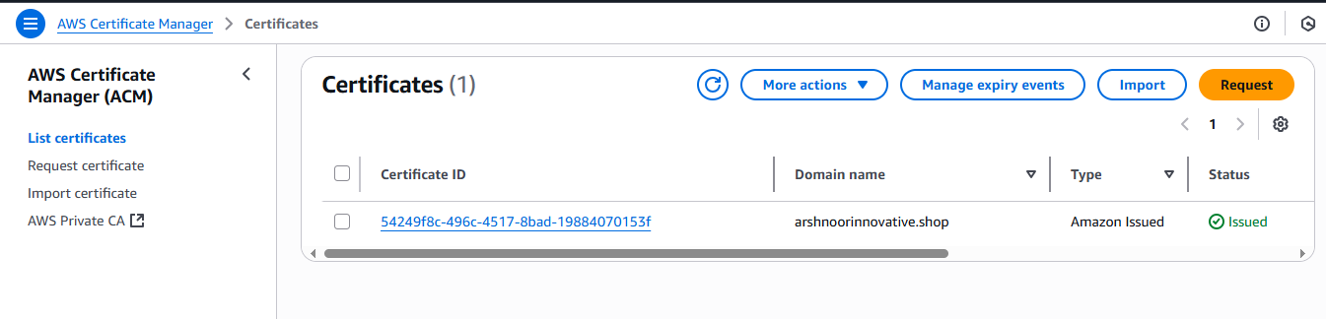

5) Create Route53 hosted zone and MAP the domain with CDN.

Ones domain is ready try create s3 bucket with same domain name

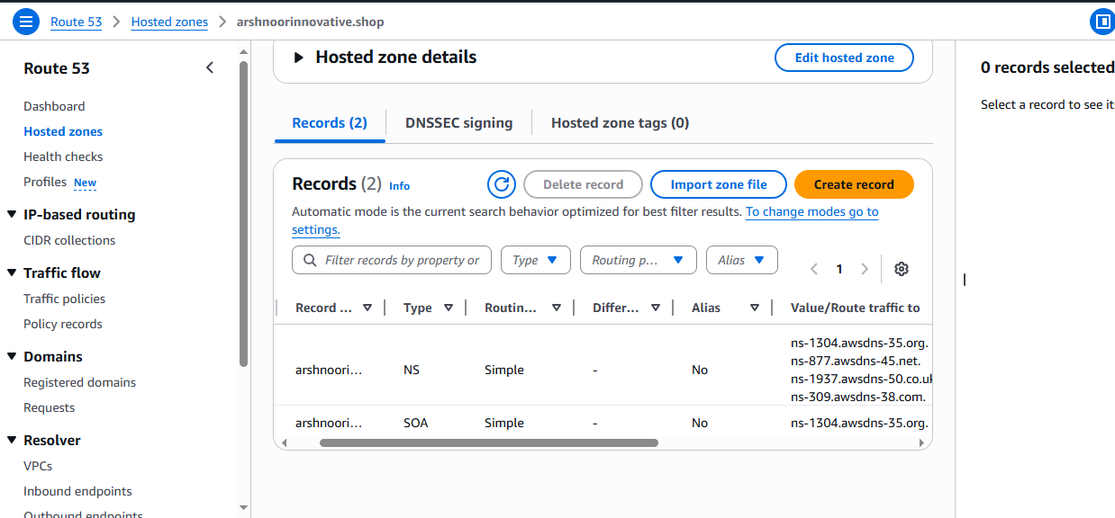

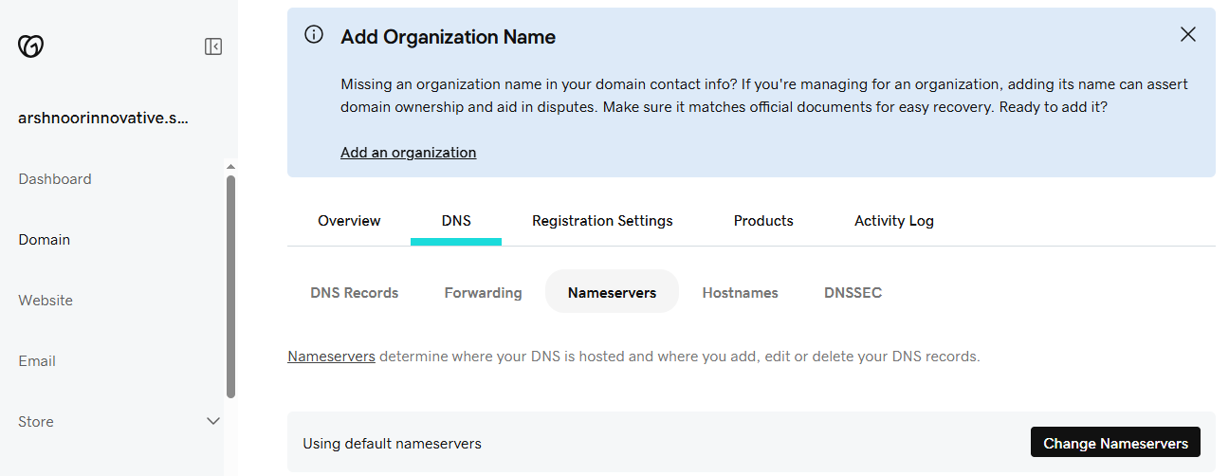

Click on chnageNameservers

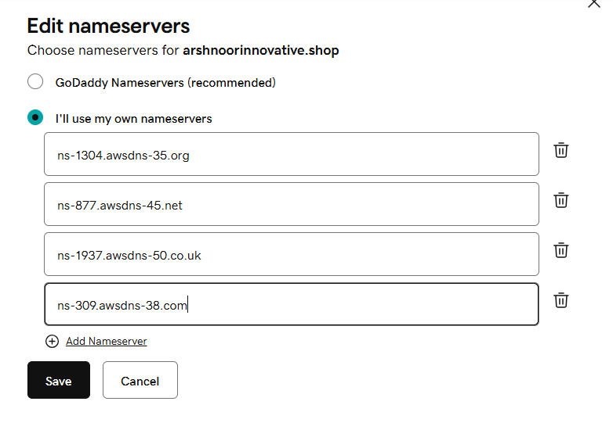

Click on save

click on continue

6) Update the index.html in s3 bucket and the updated file should be accessible by using domain name. (arshnoorinnovative.shop)



















Click on create distrubution



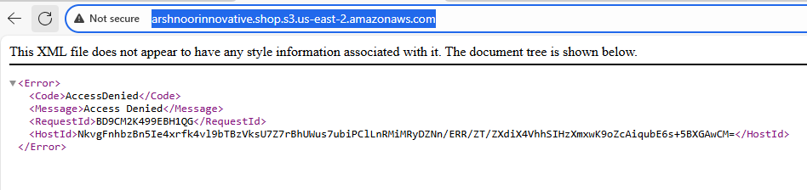

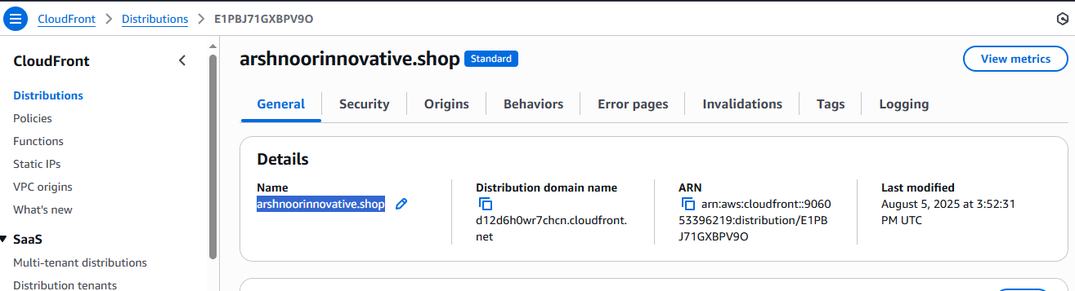

Below details Name is DNS distributed domain name DNS (hostname or this cloud front)

Means if you want to acess your S3 website, do not use S3 URL. we can use DNS name copy this and paste on the browser.

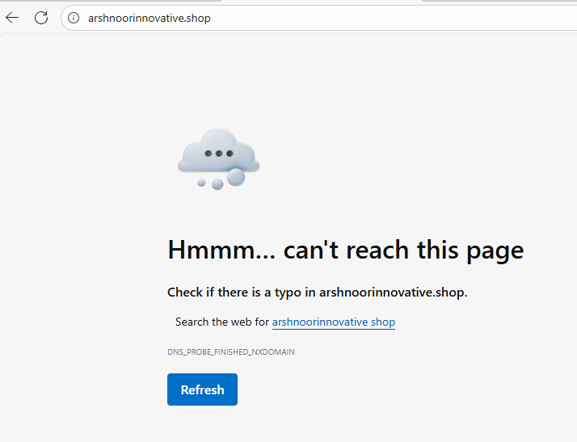

It will take time because it is still loading(deploying)

Once successfully deployed I can copy this DNS again and paste in browser then what will happen to this cloudfront we have configured S3 . So cloudfront will request the S3 and our website will display.

Note: What we have did till now I created S3 – and S3 will attached to Cloud front – and CF will attached to the R53 (this step is still pending) just I am doing testing step by step. So without testing don’t do the complete configuration.

In my case I am not as below sir got and here for sir it is showing https as secure but sir haven’t configured SSL but still it is secured. Why because cloudront is secured, CF bydeault ads SSL certificate.

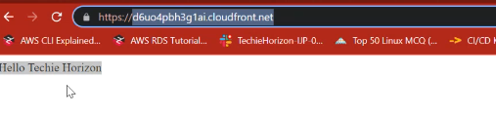

Now what we need to do is

Add our CF to R53 means whenever I try to access techiehorizon.com it will travel to C and CF willtravel to our S3 bucket.

Create record

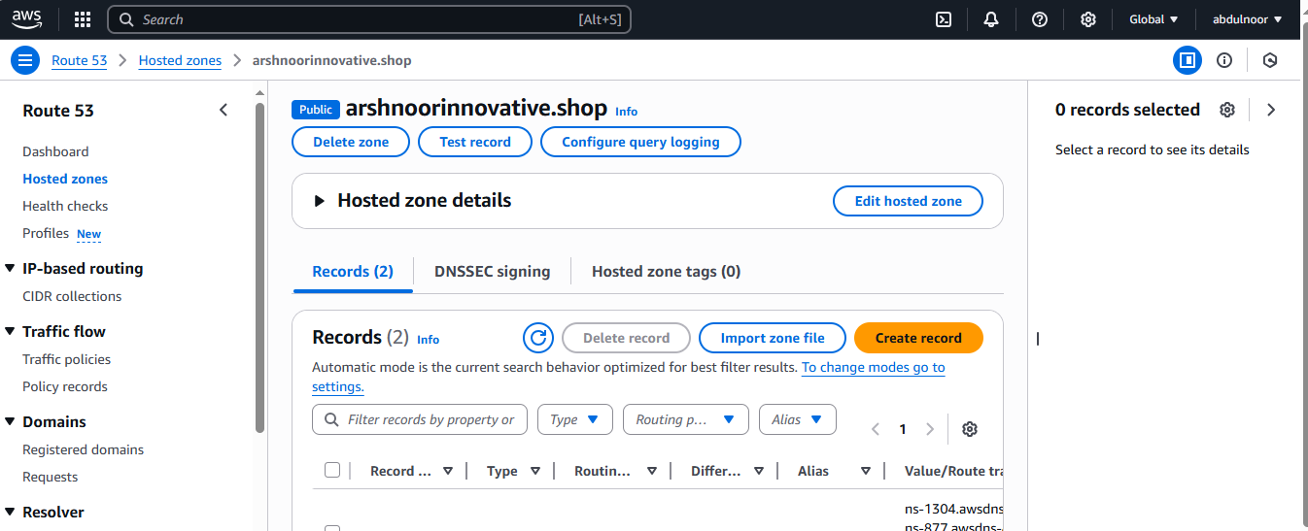

Subdomain nil

Alias: this is only option which makes R53 as unique

In interview asked what is diference b/w R53 and some azure domain or godaddy domain.

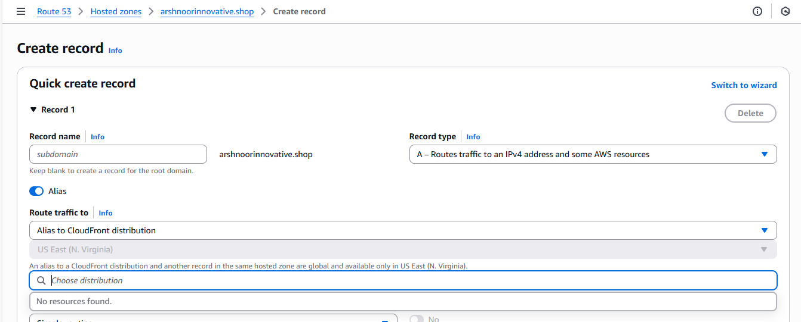

But in the above still not taking DNS name showingas no resource found. For this

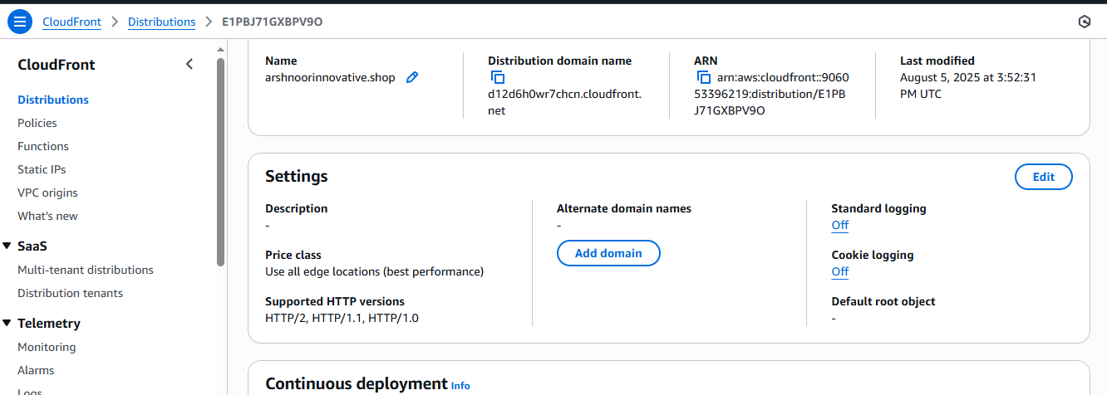

Click on Edit

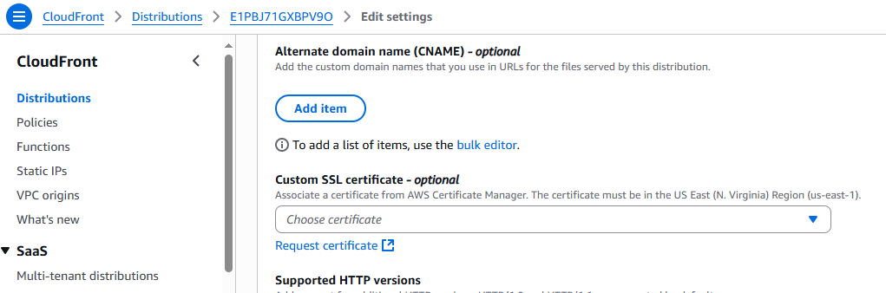

Here we need to assign SSL certificate. But it is showing None. For this we need to request a SSL certificate. Click on Request certificate.

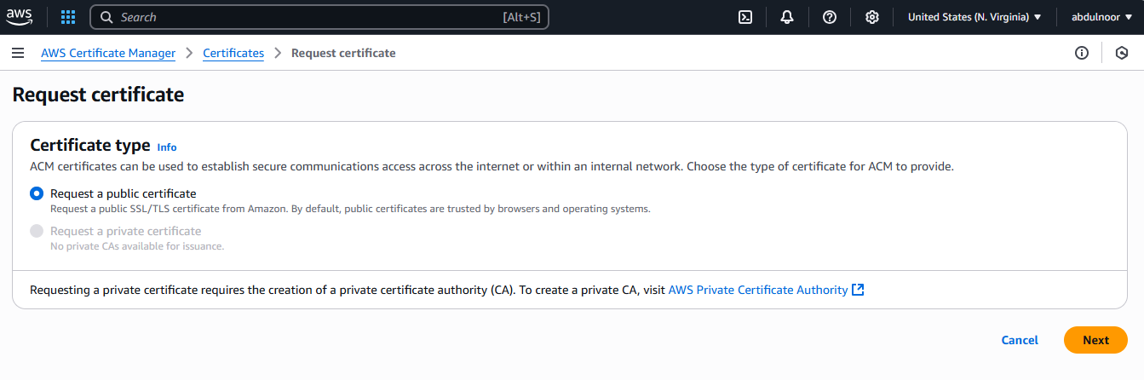

Click on Next

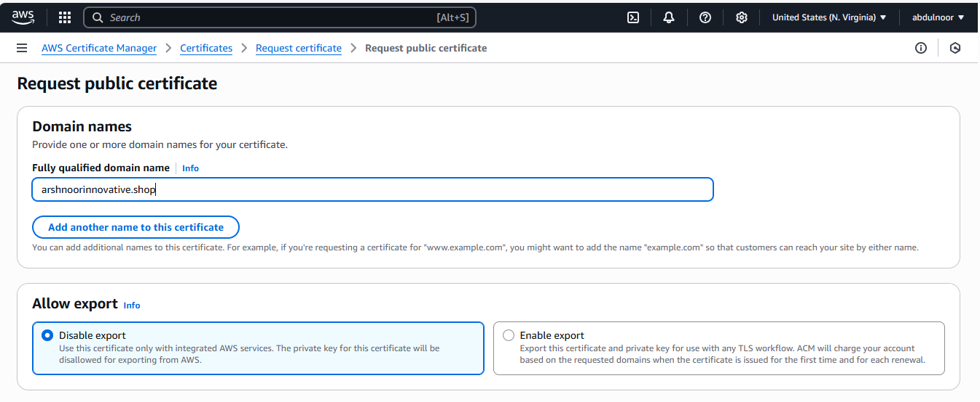

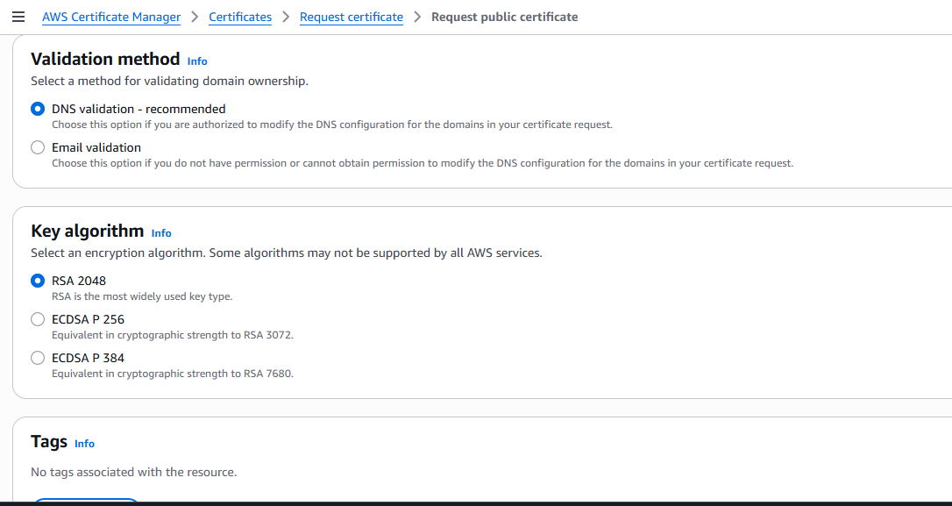

Click on request

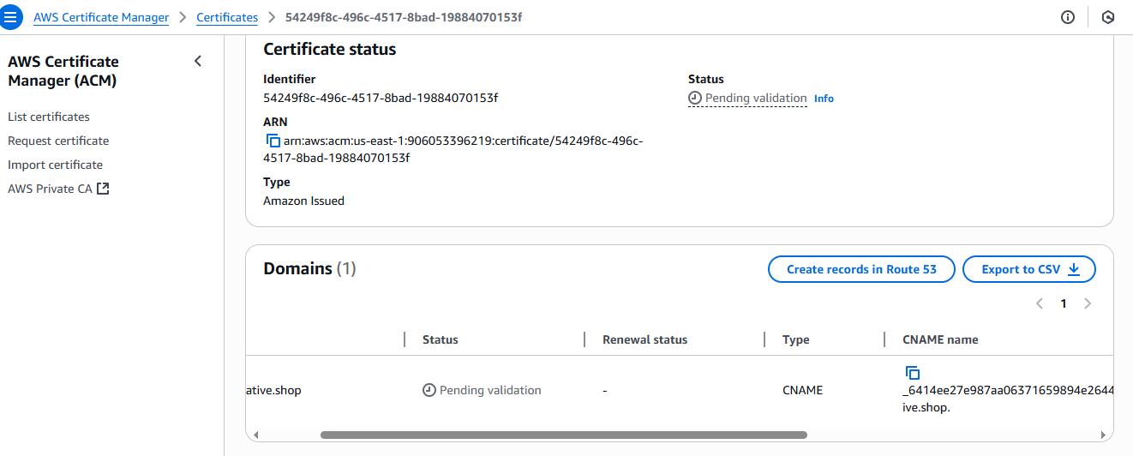

Click on certificate name as it is showing pending validation. Then it is trying to request a certificate for my domain called arshnoorinnovative.shop.

Here the above validation are pending and type CNAME is appearing why because this will only approved only when we add CNAME in R53. For this

If you want to add you can add manually go to R53 and change the record type select CNAME if not appearing stop **Alias**

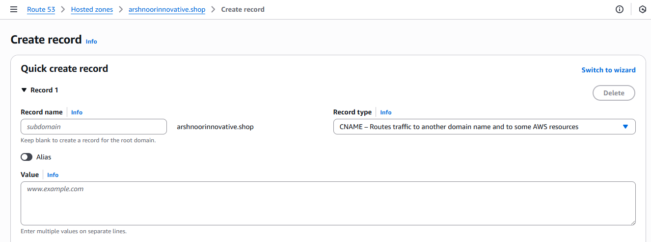

Value you can see in under CNAME

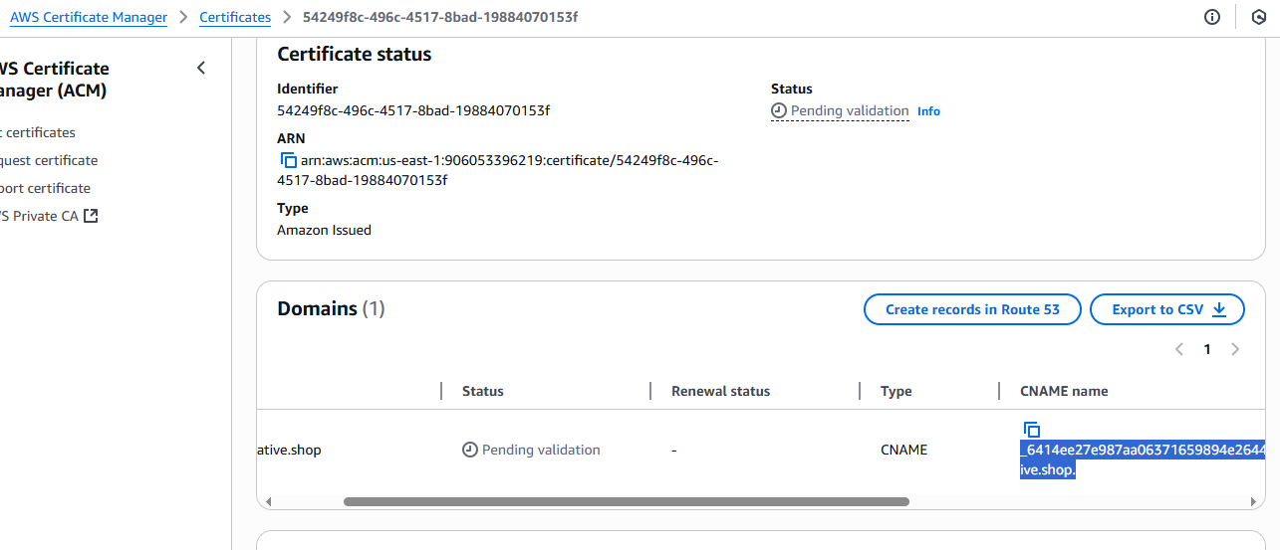copy this and paste in R53

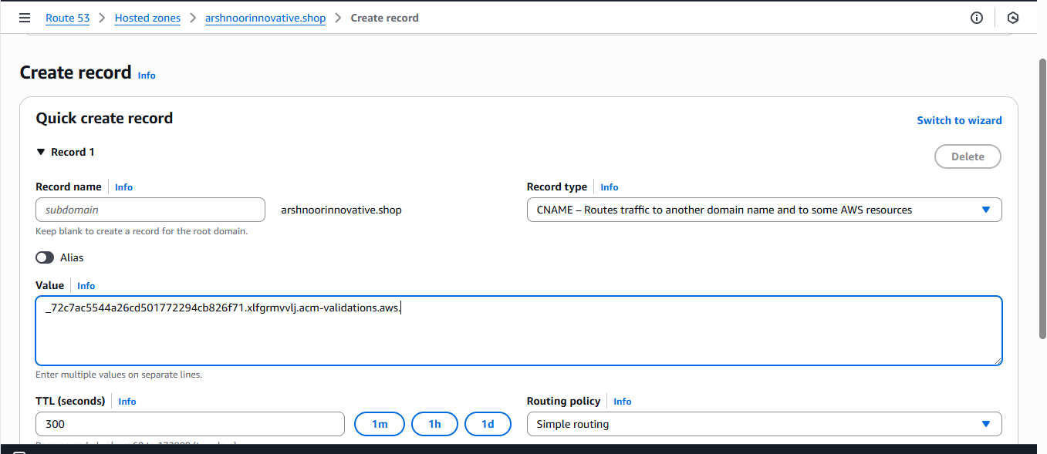

Click on create record. Or you can click on create records in CF it will automatically create record in R53. And it will not show the error.

See in below some CNAME record

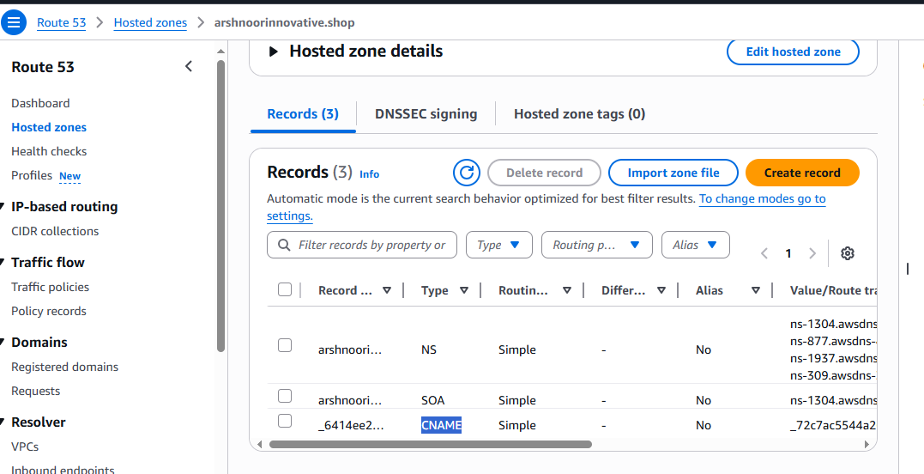

So once done it will create or issue SSL certificate within couple of seconds

Reresh the below page

But still it is pending

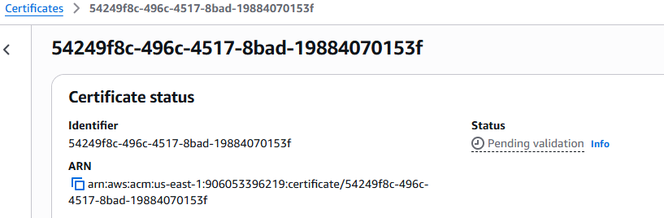

When amazon issue certificate it will do cross check this domain is configured or not in R53 and whether Cname record created or not. Then only it will issue or else it will be pending



See the status is issued

Now go to cloud front and see in the **Custom SSL certificate *– optional***  *list* it is showing our domain name.

And here in the alternate domain I can add domain as arshnoorinnovative.shop without this domain name you can not see this in the R53 means you can not find record here.

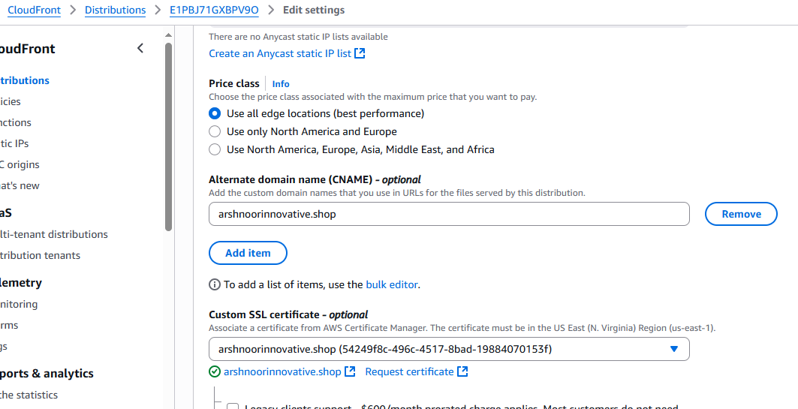

Then click on save changes

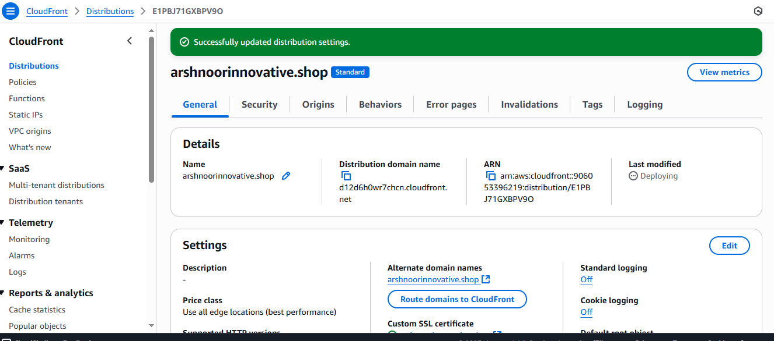

Copy **Distribution domain name** from above and paste in browser see it will work

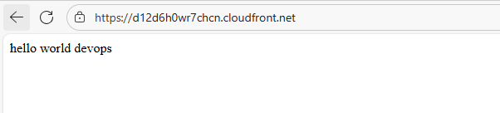

Now goto R53 create record to create DNS?

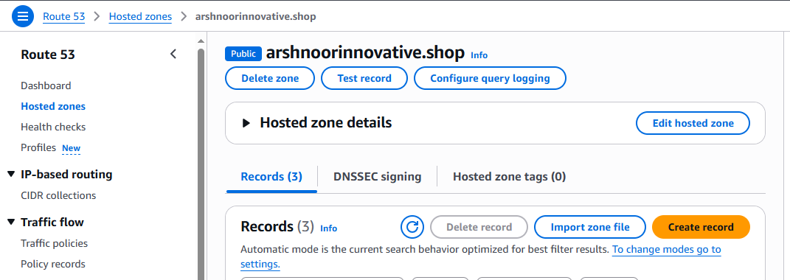

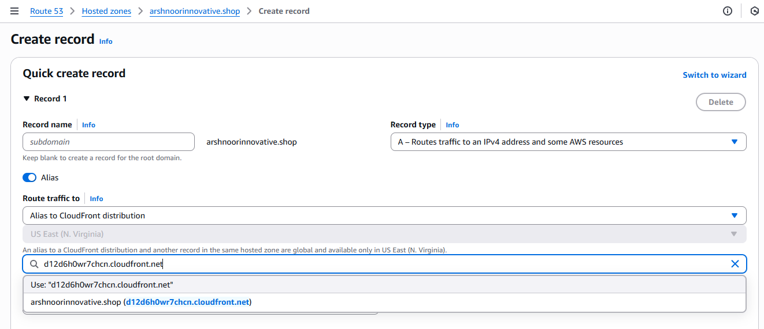 Sir didn’t get this

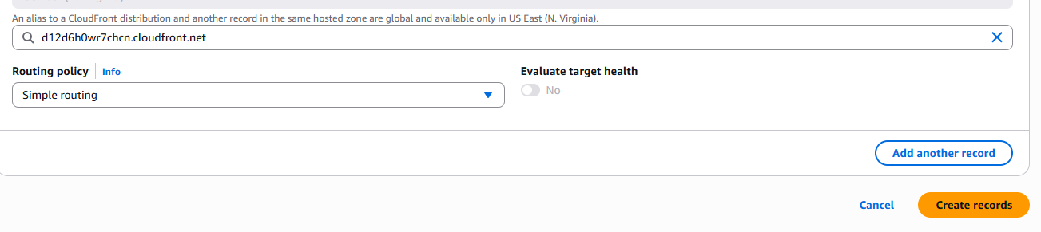

Click on create records

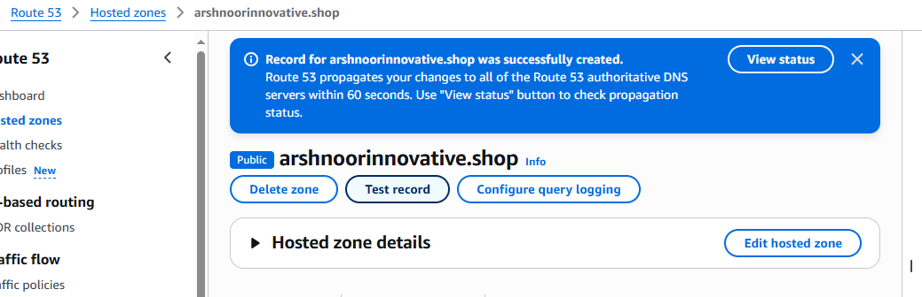

Then just type your domain name (arshnoorinnovative.shop) in the browser then it will automatically open the page If not then add https.

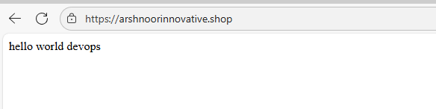

7) Share the Domain name in slack to test the connetivity.

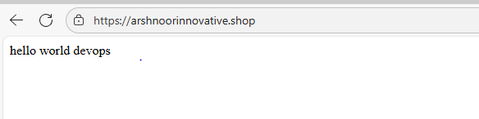

Blue colour is the cache which already stored in the edge location and reduce the replying time.so our browser is trying to store some cache.sometime

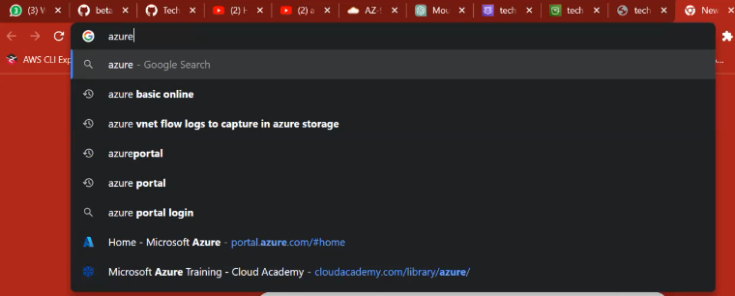

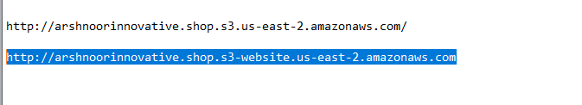

Always take the static website bucket url link